Nicola Ward

Prof. Joseph Fortunato

CIS 133

04/07/2023

Xbox — A Mobile Companion Application Used to Communicate,  
Play and Share Achievements on Xbox for Gamers

# Overview

The Xbox app, created by Microsoft for Xbox allows gamers worldwide to connect with their friends, share their achievements, and play remotely from anywhere. From personal experience with the app, some of the critical functions of a companion app are a little unorganized and stowed away in deeper sections of the application.

# Problem Statement:

Upon opening the Xbox app, users are overwhelmed on the homepage with news, links to posts created by games that users might like, their current active friends online, “jump” back in games, popular games with friends, recommended games from Game Pass and then popular games on Xbox, this homepage alone too much content, some of which isn’t interesting to users.

On the bottom navigation menu, there are options such as social, search, my library, and my profile, in that order. Selecting social, for example, opens your list of friends while additional options on the top show parties and chats. In my opinion, the main function of the companion app would be to quickly communicate with friends, jump into games remotely or start a game from the app on your console. But these essential features are some of the last options embedded in these broader topics and take various unnecessary steps to get there. This is the same for other sections of the app such as “My Library”.

# Competitor Analysis:

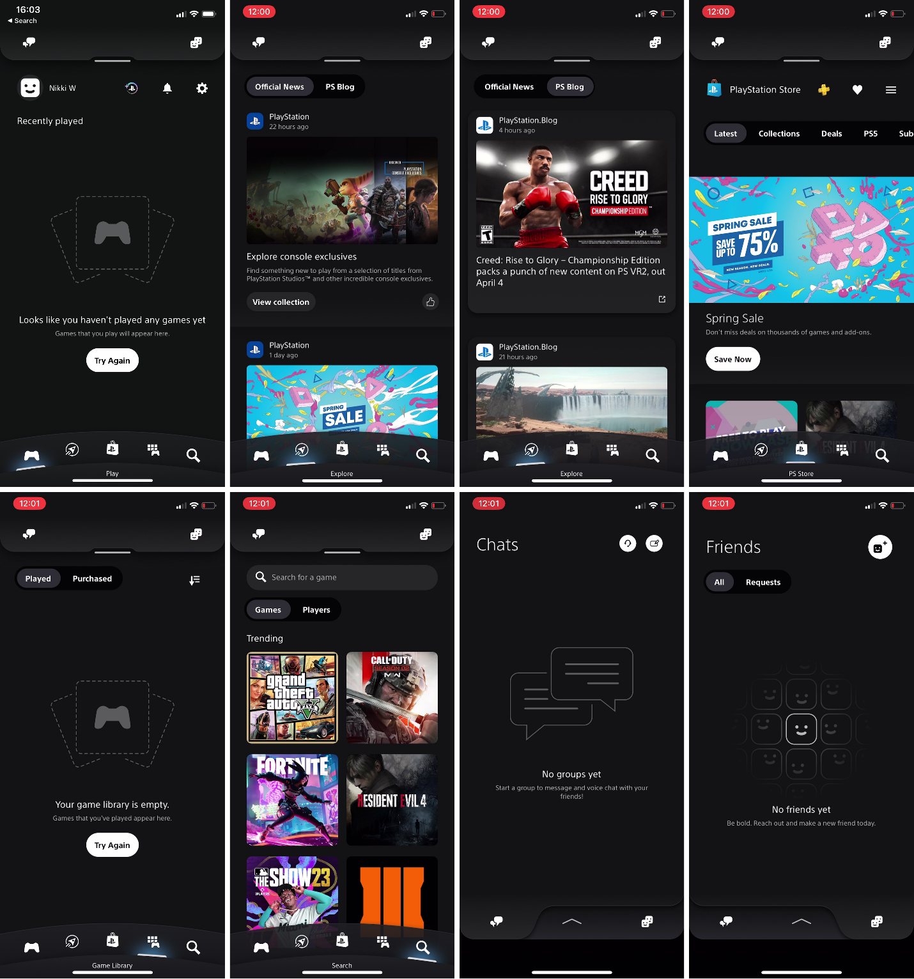

The PS APP is a similar app created by PlayStation that allows its users to access the PlayStation Network community features and remote-control functions. Their menu is quite different from the Xbox app, at first glance, it’s very well-organized and aesthetically pleasing. I am not familiar with using this app, but I can easily see that the most priority features wanted and needed in a companion app such as messages, friends, and games, all of which are easily visible and accessible without having to look under other sections.

Furthermore, they have a dedicated news section (second icon), which gives their users the choice of checking the news or not. This news section is separated into two sections, one dedicated to official news and the other to the PS blog, these sections are clear and reasonably sized, scrollable for multiple posts, and not smothering the user’s homepage with news they might not be interested in.

When investigating the store, users are met with an advertisement of an ongoing sale, scrolling down, their game icons are reasonable in size and allowed plenty of room for additional games to be shown side by side rather than occupying most of the screen. They were separated into scrollable rows under named topics such as “New Games”, “Demos” and “Coming Soon” and at the bottom of the page is a “see more” feature that provides filters such as “PS5 games”, “PS4 games”, “All deals”, “Add-ons”, “Free to play”, “VR”, “PS Plus” and “PS VR2” for further searching needs.

Under their game’s library, there are two tabs available for dividing up games, “Played” and “Purchased”. Separating these games allows users to differentiate between games played under the PS Plus feature and games they have purchased.

# Goals:

The main goal of this case study was to provide the following:

* Provide useful and positive feedback on current features provided.
* Analyze and compare a competitor’s application for potential interesting features useful in the Xbox app.
* Redesign problematic features found within the app and provide evidence of changes, showcasing improvements made to satisfy both users and the company.

# Roles & Responsibilities:

My roles and responsibilities in this case study were to determine problematic features within a frequently used app, compare it to a competitor’s app to showcase differences, and then suggest changes and provide feedback on better organization, features, and improvements for my chosen frequently used app.

# Scope & Constraints:

Constraints were found due to my limited knowledge of image manipulation, although I have attached multiple images edited to the best of my capabilities to aid with explanations and desired changes, indicating my goals and wishes to improve the current features of the Xbox app.

# Design Process:

NEW

OLD

Reorganized the home menu. I would shrink the news/advertisement tile, keeping it scrollable for additional news or popular games on Game Pass that they are trying to promote, but reducing the size allows more to be displayed at once and the home page not to be so overwhelming. I have also removed the “Official posts from games”, “Active friends”, “Recommended from Game Pass”, and “Popular on Xbox” tabs as they don’t seem like something that users would be immediately looking for when using the app. Other sections such as “Friends” are there for seeing your current active friends. Adding the user’s Gamertag would be a nice feature, creating an increased feeling of personalization users would want from a companion app.

NEW

OLD

In the social section of the application, I changed the opening page to “Chats” rather than “Friends” as this section would be one of the most important features used. As a gamer using the companion app, I’m trying to avoid the unappealing feature of on-screen keyboards on the console when replying to messages, and using the keyboard on a mobile device is much easier.

Removed the section named “Parties” as this same feature can be used under the headphone icon in the top left corner. Although, this feature in general on both platforms might slowly become irrelevant as Discord has partnered with both Xbox and PlayStation to bring its social platform to both consoles, voiding the need for the app to connect to one another’s voice chats when cross-playing.

NEW

OLD

Under the “My Library” section, I changed the starting tab from Captures to Games, as this would be one of the main reasons to be looking in here, downloading/installing games to your console remotely over trying to check recent clips and screenshots taken. Inside this Games section, being able to separate the games between owned and games that you have played through the Game Pass subscription, with options shown visually rather than obscured inside the filter icon, would be a nice feature although I don’t think it’s entirely necessary, as already mentioned, filtering options are available, but they can easily be overlooked. Separating the games between Game Pass games and owned games could be a nice added feature although I don’t think it’s necessary, filtering options are available although could be easily overlooked.

Removed the “Console” section as this can be easily accessed on the homepage from the console icon in the top right corner.

To further improve the Xbox app, I would add a store feature that is currently unavailable unlike in the PS APP. Being able to see ongoing sales and deals would entice gamers to explore and potentially purchase additional games or add-ons. The wish list feature of the PS APP would also be a useful feature for either easily accessing and purchasing your most desired games or easily gifting family and friends their most wanted games. An additional feature that would benefit the Xbox app would be the “options” menu (three-line icon) within the store, this would open a small popup menu that allows gamers to manage their payment methods, redeem codes, manage subscriptions, and view a history of their transactions without having to navigate outside of the application.

# Outcomes & Lessons:

With these small changes, I believe it would improve the user’s experience when using the Xbox companion app. Implementing the store section advertising sales and deals can entice gamers into purchasing new games. The options feature implemented within the store section negates the tedious need to navigate outside of the app to redeem codes or manage payment options.

Lessons learned through this case study are that nothing is as easy as it seems, a big company like Microsoft developing an app has already taken a lot of UI and UX design aspects and considerations into account, so further improving their app proved hard, although, from personal experience using the application, I was able to voice my annoyances and help improve and design some new features that would benefit myself and hopefully others who use the companion app.